Grandmother
The poem takes place in the grandmother's house, possibly later in the day, when she has finished her chores.
In the poem, a young woman/girl describes a meeting with her grandmother. She hasn't planned on having a long conversation with her ("I was simply/ going to say 'Salaam' and walk away"'). However, when she asks her grandmother how she feels, her grandmother's unexpected but honest answer causes the speaker to come to an important realization (understanding). She becomes emotional and filled with guilt because she realizes that she was going to walk away, ignoring her grandmother without giving her the opportunity to share her thoughts and feeling with someone. She realizes that her grandmother wanted to share her experiences with someone even if they were simple and insignificant. Her eyes fill with tears because she feels guilty that she did not intend to give up any of her time to have a real conversation with her grandmother. The speaker realizes that a routine greeting is not sufficient, and that elderly people, in this case her grandmother, may be lonely, and need someone to listen. She realizes that she has to take the time to relate to her grandmother as a human being who deserves time attention, respect and appreciation.
The message of the poem: The central idea of the poem is the way we relate to members of our family, especially the elders. The message conveyed in this poem is that we mustn't take them for granted. The poem proves to us how important it is to listen to them and show care and sympathy. It also shows that family ties, in general, are very important and that we should spend more time with our loved ones.
Distinguish Different Perspectives
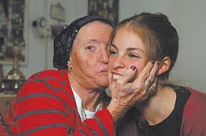
The speaker looks at her grandmother from a different perspective. She views her life through her grandmother's eyes and realizes that she has selfish. She understands that she has related to her impersonally, as just another old person whose life will soon be over, and not with the love and appreciation that she should show to her grandmother.

